ANNEX II + III: TECHNICAL SPECIFICATIONS + TECHNICAL OFFER

Contract title: Supply of Visibility items for EUAM activities

Lot 2 – Promo Items
Publication reference: EuropeAid/139860/ID/SUP/UA (EUAM-18-47)
Columns 1-2 should be completed by the Contracting Authority
Columns 3-4 should be completed by the tenderer
Column 5 is reserved for the evaluation committee
Annex III - the Contractor's technical offer
The tenderers are requested to complete the template on the next pages:
- Column 2 is completed by the Contracting Authority and shows the required specifications (not to be modified by the tenderer),
- Column 3 is to be filled in by the tenderer and must detail what is offered (for example the words “compliant” or “yes” are not sufficient)
- Column 4 allows the tenderer to make comments on its proposed supply and to make eventual references to the documentation
The eventual documentation supplied should clearly indicate (highlight, mark) the models offered and the options included, if any, so that the evaluators can see the exact configuration. Link to the web site where the description of the proposed model exists is not enough. It is obligatory to add the detailed description of specification offered.
It is also obligatory to provide samples for each of the following items listed below: PI-1, PI-2, PI-3, PI-4, PI-5, PI-6, PI-7, PI-9, PI-10, PI-12, PI-14, PI-16, PI-17, PI-18, PI-19, PI-21, PI-26. Colours, dimensions of samples and the logo can be different from the colours, dimensions of items and the logo detailed below, but basic parameters and characteristics of items (custom design where required, type and quality of material, types of finishing/branding operations, etc.) shall be corresponding to requirements of the related items and shall not be of the quality lower than the quality requested.
Sample items submitted as part of Tenderer’s offer are to be submitted free of charge. Samples of the winning Tenderer will be retained for quality verification purposes for future deliveries; samples of unsuccessful Tenderer(s) will be returned if specifically requested by the Tenderer.
Offers that do not permit to identify precisely the models and the specifications and/or for which the samples as required above were not provided may be rejected by the Evaluation Committee.
The offer must be clear enough to allow the evaluators to make an easy comparison between the requested specifications and the offered specifications.
1.  Item Number | 2.  Specifications Required | 4.  Specifications Offered | 5.  Notes, remarks,  ref to documentation | 6.  Evaluation Committee’s notes
PI-1 | Reflective slap-on bracelet  (ISO 20471:2013 compliant)  Front side material: Reflective PVC  Backside material: soft hypoallergenic material  Colour: assorted rainbow colours  Printing: 1+0, maximum 15 x 3 cm, EUAM website, Twitter and FB logos  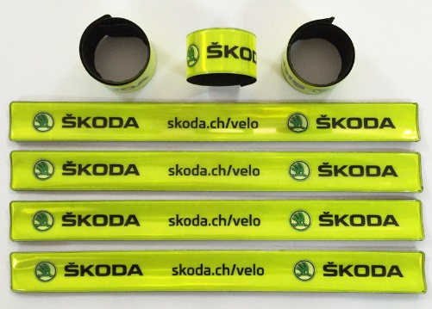
PI-2 | Thermo cup non-coated  Useful volume: 300 ml  Exterior: silver non-coated, polished metal  Interior: vacuum insulated stainless steel, double wall  Super clean finished process, tough against stains and odours  Threaded lid with a silicone seal that protects against leaks. The lid should have a lockable drink-through opening with a silicone seal that protects against leaks  EUAM logo: 3+0 silk screen printing, 2.5*2.5 cm  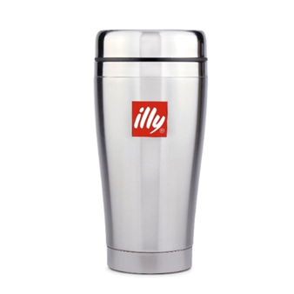
PI-3 | Mug  Volume: 250 (+/- 15%) ml  Exterior material: pottery (matt, stainless finish)  Interior: glossy  Colour: white (matt)  EUAM logo: 2+0 printing, maximum 5 x 5 cm  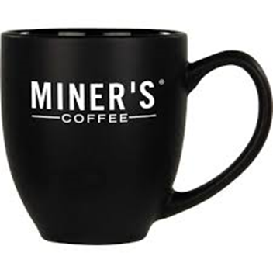
PI-4 | Cuddly toy  “Teddy”/”Sparkie”/”Windsor” Bear in a T-shirt  Size: 20 +/- 20% cm  Material: Plush or equivalent  Colour: sand, white, yellow, light-brown, grey  EUAM logo: 2+0, emroidered or printed, 2.5cm by 2.5cm  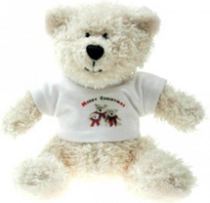
PI-5 | Eco bag  Size: length 40 cm, height 45 cm, width 5 (+/- 40%) cm, length of handle: 35 (+/- 15%) cm  Material: 100 % cotton, density 280g/m2, reinforced bottom  Colour: natural unbleached cotton  Magnetic button - up to 1,5 cm at the top of a bag.  An additional inside pocket for keys and documents, not less than 10 x 10 cm  EUAM logo: 3+0, silk-screen printing or thermal transfer, maximum 20 x 20 cm  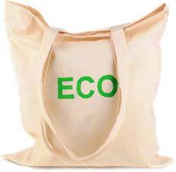
PI-6 | Soft backpack  Size: width – 40 cm x height - 45cm  Material: nylon fabric with density not less than 200 den, water repellent  Colour: blue or yellow  Bucket bag construction with a tightening neck, String handles  Reinforced cross stitching at handles attachment points.  Length of handles: not less than 80 cm +/-10 % m each.  Should have a high visibility reflective stripe (1,5 cm wide as a minimum requirement) on a horizontal front side of a soft backpack.  Printing at 1 point: 4+0 silk-screen printing, 20 x 20 cm  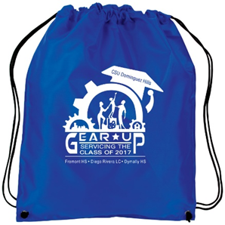
PI-7 | Umbrella “S” size  Closed length: 27 cm (+/-10%)  Width of canopy: appr. 87cm (edge to edge) (+/-10%)  Canopy depth: 23 cm (+/-10%)  Colour: Pantone Reflex Blue C  Material: water repellent nylon  Build materials: Fiberglass, anodized aluminium  Plastic handle  Wind-resistant and storm-proof design umbrella  Configuration: Automatic (pushbutton)  Printing at 1 point: 2+0 silk screen printing, 8 x 8 cm  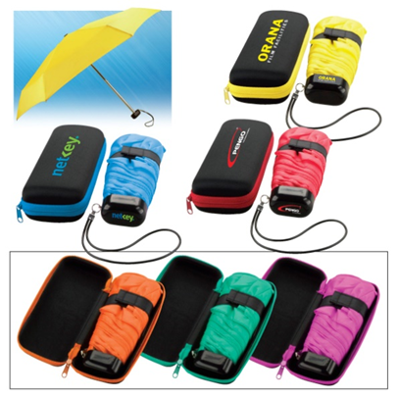
PI-8 | Umbrella “L” size  Closed length: 102 cm (+/-10%)  Width of canopy: 130 cm (edge to edge) (+/-10%)  Colour: Pantone Reflex Blue C  Material: water repellent nylon  Build materials: Fiberglass, anodized aluminium  Wooden handle and wooden peaks of the spikes  Wind-resistant and storm-proof design umbrella  Configuration: Half - automatic (pushbutton)  Printing at 1 point: 2+0 silk screen printing, 10 x 10 cm
PI-9 | Eco pen  Made from recycled carton and sustainable wood  Blue ink, fine point  Printing at 1 point: 3+0, EUAM logo 0.5 x 0.5 cm, and the name of the Mission (The European Union Advisory Mission to Ukraine) maximum1 cm height x 6 cm length  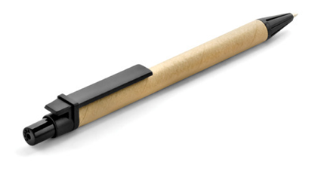
PI-10 | Polo-shirt  Material: breathable cotton pique, custom-tailored, high quality, 180g/m2  Color: white with dark blue colour on sleeve and collar  Polo collar, three button fastening, normal sleeve.  EUAM logo: embroidered, 2+0 (dark blue and yellow), 60х60 mm  Available in sizes: S, M, L, XL, XXL for men and women  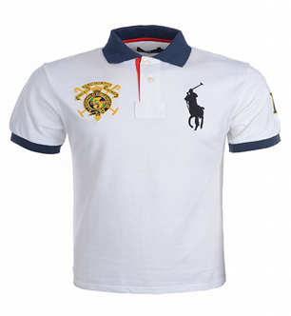
PI-11 | T-shirt  Material: high quality 100% cotton 150g/m2, custom-tailored.  Colour: White  Classic t-shirt, round-shaped collar  EUAM logo: 2+0 silk screen printing, 60x60 mm  Available in sizes: S, M, L, XL, XXL for men and women  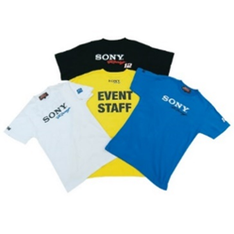
PI-12 | Lapel pin  Size d -20 (+/- 10%) mm, round shape  Metal "button", metal "brass" coloured, metal thickness 1 mm  "Butterfly" construction  EUAM logo: enemel (RAL 5002 or equivalent) + chemical etching.  Lapel pin should be placed in a plastic gift box  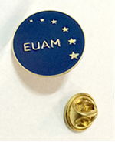
PI-13 | Lanyard  Lanyard with automatic safety release  Size: length 86-92 cm, width 2 cm  Material: polyester  Colour of a lanyard lace: Pantone Reflex Blue C blue  Customizable with a breakaway function and detachable buckle for security reason  End fitting: Swivel hook  Printing: 2+2 sublimation printing on the full length  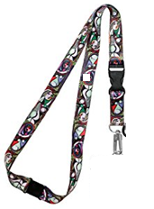
PI-14 | Set of table flags  Set of 2 table flags on the metal stand (European Union flag and blue flag with EUAM logo printed)  Flag size: 150 mm X 230 mm  Flag material: Polyester silk,  Flag type: reversible for European Union flag, non-reversible for flag with EUAM logo (second side background blue color)  Table stand for 2 flags “V” shape, suitable for office desks  Table stand material: stainless steel (colour silver)  EUAM logo: 3+0 printing  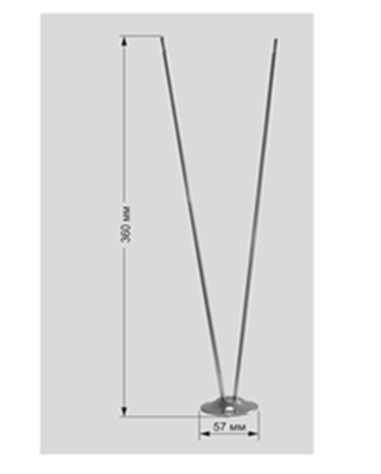
PI-15 | Roll up banner  Zap construction ”Maxibit” or equivalent:  Aluminium alloy Roll-up with telescopic pole, Gripper profile and fast cassette-loading graphics, Flight Bag.  Material banner fabric Blackout  Full colour printing 720-1440 dpi  Size: 120*220 cm  Instruction on how to assemble it should be included
PI-16 | Nickel plated business card case  Suitable for standard size for business cards (8.9 x 5.1 cm)  Volume: minimum for 20 cards  Colour: grey/silver  Clam shell firm construction  EUAM logo: laser engraving, maximum 2.5 cm  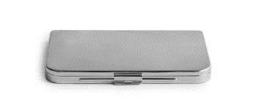
PI-17 | Flash-drive USB 3.0 Flash Drive 64 Gb  Transcend, SanDisk, Kingston or equivalent  Model with keychain and a removable cap (360 degrees)  Memory: 64 Gb  Material: metal or plastic  Colour: Blue, yellow or white  Water proof and shock resistant  Interface: USB 3.0  Reading speed: not less than 50 MB/sec  Writing speed: not less than 15 MB/sec  Operating System compatibility: Windows 10, Windows 8.1, Windows 7, Mac OS X, Linux v.2.6.x  EUAM logo: 2+0 silk screen printing, maximum 1.5 cm2  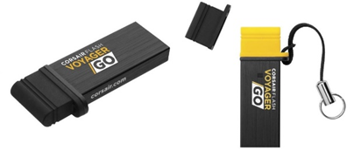
PI-18 | Baseball cap  6 panel baseball cap  Material: 100 % cotton  Colour: blue  Strap plastic fastener or fabric + metal buckle  One size fits all  EUAM logo: embroidered, 2+0, maximum 7 x 7 cm  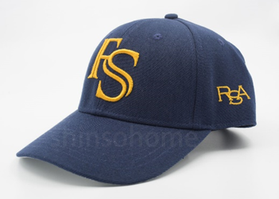
PI-19 | Two-sided tippet, made from two cloths  Size: 40х120 cm  Tippet material: satin: 85g/m2  Tippet printing: full surface full colour heat transfer printing  Each should be packed in an individual gift box.  Box is material: carton with a lodgement and tissue paper Artelibris air bag blue navy/ Artelibris air bag blue/or equivalent.  Box printing: 3+0 silk screen printing, full surface  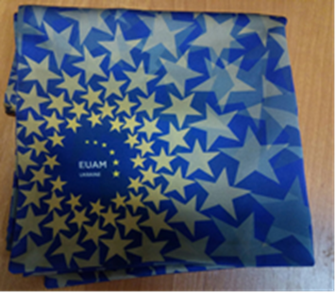
PI-20 | Whistle for kids, type 1  Size: Up to 10 cm  Shape: in traditional UA character (ruster)  Material: ceramics with traditional UA ornament  Individual packing: PVC/PE sleeve with an adhesive fastening  EUAM logo: 3+0, maximum 1 cm2, in whatever appropriate method  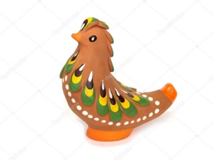
PI-21 | Whistle for kids, type 2  Size: Up to 10 cm  Shape: in traditional UA characters  Material: wood with traditional UA ornament  Individual packing: PVC/PE sleeve with an adhesive fastening  EUAM logo: 3+0, maximum 1 cm2, in whatever appropriate method  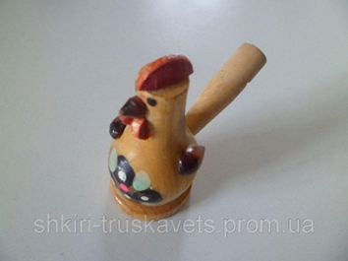
PI-22 | Whistle for kids with a key-chain, type 3  Size: Ø 1,5 cm; length – 7 cm (+/-10%)  Material: anodized aluminum  Colour: RAL 5002  “Whistleblower” on the opposite side along the whole length of the whistle  Individual packing: PVC/PE sleeve with an adhesive fastening  EUAM logo: laser engraving, 1 x 1 cm  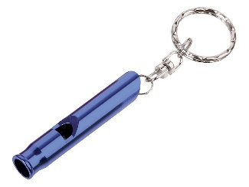
PI-23 | Whistle for kids, type 4  Size: 5 x 1.5 x 2 cm (+/-10%)  Length of a lanyard: 40 cm  Material: durable plastic with a matching colour lanyard  Colour: RAL 5002  Individual packing: PVC/PE sleeve with an adhesive fastening  EUAM logo: 2+0 silk screen printing, 1 x 1 cm  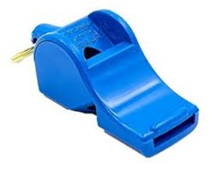
PI-24 | Branded pins in various shapes  Size: 2 (w) x 3 (h)cm  Metal "button", metal "brass" coloured, metal thickness 1 mm  Shapes: Figures of a policeman, a service dog, a police car, a police cap  Butterfly construction  Individual packing: PVC/PE sleeve with an adhesive fastening  Printing: chemical etching, 4+0 enamel, epoxy, full surface  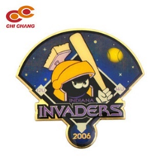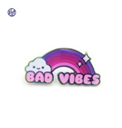
PI-25 | Key-tag “Remove before flight”  Double-sided embroidered fabric key tag (reinforced on the inner side by 1 mm thickness plastic equal to a size of a key-tag, sewed in the inner part of the key-tag)  Size: 13 x 3 cm  Colour: blue  A metal eyelet with a metal key-ring attached  Embroidery:  At the whole length of the key-tag  On one side - “Remove before flight”, on the other side - EUAM logo and the name of the Mission  Font size: 1,1cm  Colour: yellow  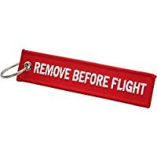
PI-26 | Ball -point pen  Klio, Senator pen or equivalent, retractable  Barrel: blue, yellow or white.  Push-clip: plastic.  Length of the barrel – not less than 12 cm and the fill in should be blue and proportionate to the size of the barrel.  Printing on one side: 2+0 silk-screen printing, EU stars and the full name of the Mission “European Union Advisory Mission to Ukraine“  Printing size: not more than 30% of the surface of a pen  Printing on the clip: 2+0 silk-screen printing, EUAM logo : 0,5 x 0,5 cm  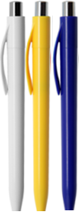

Please note that the image is an idea only and does not necessarily reflect the image of the product expected from you

