ANNEX II + III: TECHNICAL SPECIFICATIONS + TECHNICAL OFFER

Contract title: Supply of Visibility items for EUAM activities

Lot 1 – Printed Visibility Items
Publication reference: EuropeAid/139860/ID/SUP/UA (EUAM-18-47)

Columns 1-2 should be completed by the Contracting Authority
Columns 3-4 should be completed by the tenderer
Column 5 is reserved for the evaluation committee
Annex III - the contractor's technical offer
The tenderers are requested to complete the template on the next pages:
- Column 2 is completed by the Contracting Authority and shows the required specifications (not to be modified by the tenderer),
- Column 3 is to be filled in by the tenderer and must detail what is offered (for example the words “compliant” or “yes” are not sufficient)
- Column 4 allows the tenderer to make comments on its proposed supply and to make eventual references to the documentation
The eventual documentation supplied should clearly indicate (highlight, mark) the models offered and the options included, if any, so that the evaluators can see the exact configuration. Link to the web site where the description of the proposed model exists is not enough. It is obligatory to add the detailed description of specification offered.
It is also obligatory to provide samples of the following items listed below: P-1, P-2, P-3 and P-4 (one of each); P-5 or P-6 (one out of two); P-7, P-8 or P-9 (one out of three). Format of samples and the quantity of sheets may be different from the format and quantity detailed below, but basic parameters and characteristics of items (custom design where required, the quality of paper, scope of required post-press operations, colour scale etc.) shall be corresponding to requirements of the related items and shall not be of the quality lower than the quality requested.
Sample items submitted as part of Tenderer’s offer are to be submitted free of charge. Samples of the winning Tenderer will be retained for quality verification purposes for future deliveries; samples of unsuccessful Tenderer(s) will be returned if specifically requested by the Tenderer.
Offers that do not permit to identify precisely the models and the specifications and/or for which the samples as required above were not provided may be rejected by the Evaluation Committee.
The offer must be clear enough to allow the evaluators to make an easy comparison between the requested specifications and the offered specifications.
1.  Item Number | 2.  Specifications Required | 3.  Specifications Offered | 4.  Notes, remarks,  ref to documentation | 5.  Evaluation Committee’s notes
P-1 | A5 Notepad, type 1  Size: A5  Customized design of the cover page.  Cover: 4+0 printing, paper 250g/m2, coated.  Block: 40 sheets, 4+0 printing, paper 120g/m2, checked or lined www.euam-ukraine.eu , FB, Youtube and Twitter symbols at the bottom of each page, uncoated, dull.  Binding – metal vertical spiral (with coating).  The cost of design of the cover page should be included in the calculation.  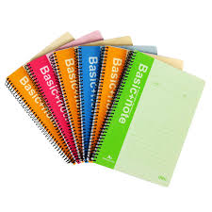

P-2 | Daily Planner for 2019/2020/2021  Format: 14,5 x 20,6 cm  Cover: faux leather or equivalent, colour navy blue,  EUAM logo: 3*3 cm  Block: min. 352 pages, paper 80 g/m2, creamy or white, corners with perforation, ribbon bookmark, dated.  As a minimum requirement the block should contain: pages with alphabet for phone numbers and addresses.  Language: Ukrainian, English (double).  Flyleaf: should provide UA/EU-related images or information  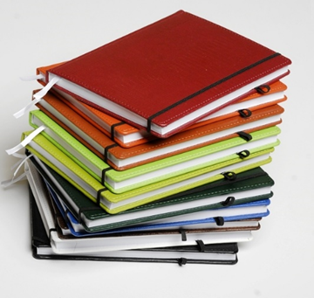
P-3 | Leaflet  Format: А4 (unfolded), 2 fold creasing  Printing: 4+4  Enameled paper 250 g/m2, matt lamination, partial UV polish  Delivery: folded, packed in accordance with the instructions of a contract manager (shrink film or craft paper).
P-4 | Paper folder  Size: 220 х 317 mm when assembled  Paper: Cardboard 300 g +/-10%, die-cutting  EUAM logo: 2+0 printing, size: 42 x 45 mm  Partial UV polish, laminated (matte)  Delivery: assembled, packed in accordance with the instructions of a contract manager (shrink film or craft paper)  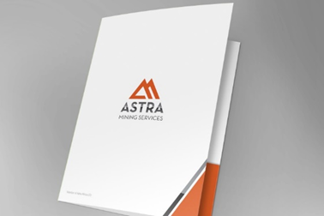
P-5 | A5 Notepad, type 2  Size: A5  Customized design of the cover page.  Cover: 4+0 printing, cardboard 275g/m2 (+/-10%), Arktika, Zenit or equivalent (white on the back side), matte lamination 1+0, partial lacquer 1+0.  Block: 50 sheets, 4+0 printing, paper 90g/m2 (+/-10%), plain and lined (approx. 50/50% of order volume) www.euam-ukraine.eu , FB, Youtube and Twitter symbols at the bottom of each sheet.  Binding: Thermal glue on a short side.  The cost of design of the cover page should be included in the calculation.
P-6 | A6 Notepads  Size: A6  Customized design of the cover page.  Cover: 4+0 printing, cardboard 275g/m2, (+/-10%), Arktika, Zenit or equivalent (white on the back side), matte lamination 1+0, partial lacquer 1+0.  Block: 50 sheets, 4+0 printing, paper 90g/m2 (+/-10%), plain and lined (approx. 50/50% of order volume) www.euam-ukraine.eu , FB, Youtube and Twitter symbols at the bottom of each sheet.  Binding: Thermal glue on a short side.  The cost of design of the cover page should be included in the calculation.
P-7 | Paper Bag “S” size  Format: A5 folded, width 10 cm  Carton: 220 g/m2, white, coated  Handles: braided string handles fastened to 4 metal eyelets (coated)  EUAM logo: 2+0 printing, size 3*3 cm  Matt lamination 1 + 0, partial UV glossing 1 + 0  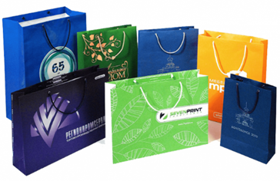
P-8 | Paper bag “M” size  Format: A4 folded, width 10 cm  Carton: 220 g/m2, white, coated  Handles: braided string handles fastened to 4 metal eyelets (coated)  EUAM logo: 2+0 printing, size 3*3 cm  Matt lamination 1 + 0, partial UV glossing 1 + 0  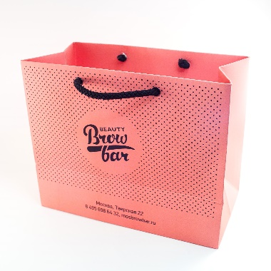
P-9 | Paper bag “L” size  Format: A3 folded, width 10 cm  Carton: 220 g/m2, white, coated  Handles: braided string handles fastened to 4 metal eyelets (coated)  EUAM logo: 2+0 printing, size 3*3 cm  Matt lamination 1 + 0, partial UV glossing 1 + 0  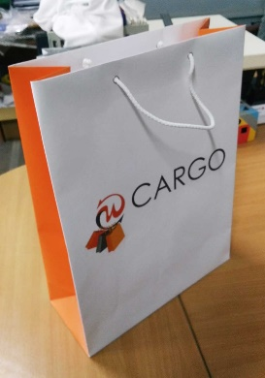

Please note that the image is an idea only and does not necessarily reflect the image of the product expected from you

